Collicity — Product Specification (Draft v0.1)
Oct 5, 2026 · @Philip Maynard

1. Overview
Collicity is a cross-platform AI automation workspace: people describe work in plain language, and Collicity turns it into named, budgeted, scheduled assignments made of tasks that act across their apps — always with the user's own identity and never beyond the user's own permissions.
It ships as two editions on one codebase:
- Home — personal and household automation (meal planning, shopping, smart-home routines), with consumer sign-in.
- Enterprise — team and departmental automation (e.g., a security posture report built from Qualys, Splunk and Intune), with central administration, SSO, model governance and security monitoring.
Problem. AI assistants answer questions but rarely finish multi-step work across systems. Tools that do automate (iPaaS, RPA, agent frameworks) usually run as over-privileged service accounts, reveal cost only on the invoice, and give no signal when the model is wrong. Collicity's bet is that delegated identity, hard budgets and a supervising quality loop are what make people trust an agent with real work.
Differentiators (each has its own section):
- Zero-trust connectors that act strictly on behalf of the user (§6).
- Cost-first design: estimates before running, hard budget caps, cheapest-capable-model routing (§8, §9).
- A supervisor that catches bad output and learns which models work for which tasks (§9).
- Templates that keep recurring outputs consistent (§10).
- Time, event and location triggers across desktop, web and mobile (§11).
Conventions. MUST = required for the edition's launch; SHOULD = expected, may slip a release; MAY = optional. Priorities: P0 = launch-blocking, P1 = fast follow, P2 = design for it now, build later. Requirement IDs (e.g., CON-03) are stable for traceability. Numeric targets are proposals to validate.

Product invariants
Five rules hold in every edition, client and connector. Each is enforced outside the model, has its own automated test suite and a zero-target guardrail in §19; weakening one requires a security review.
- Permission ceiling. Effective permission = the user's own access ∩ scopes the user consented to ∩ actions the task declared ∩ admin policy, enforced at the connector gateway, never by the model (CON-02).
- No action without authorization. Every connector action traces to an authorization: the owner's acceptance of the assignment version for its declared reads, and an approval or a still-valid pre-authorization for every side effect (ASG-11, PAY-02, PAY-03).
- No credential reaches a model. Tokens, keys and secrets never enter prompts, model outputs, logs or third parties (CON-04, SEC-03).
- No AI-cost call without reserved budget. No model or paid API call starts until its worst-case cost is reserved against the budget (BUD-03).
- Untrusted content cannot expand authority. Data from connectors, documents, emails or web pages can never add permissions, connectors, recipients, budget or approvals (CON-10).

2. Goals and non-goals
v1 succeeds if people trust Collicity to finish recurring work end to end, with zero budget overruns and zero permission violations. Targets are measured 6 months after launch.
# | Goal | Measure | Proposed target
G1 | People finish real multi-step work, not just chat | Active users with ≥1 assignment that completed ≥3 successful runs | 40%
G2 | No spend surprises | Runs that exceed their authorized budget | 0 (hard invariant)
G3 | Cheaper than "always use the best model" | Net cost per verified-successful task (worker + supervision + retries) vs. a frontier-model-only baseline | ≥40% lower
G4 | Trustworthy output | Escaped defects per 100 runs, estimated from the independent evaluation set (SUP-06) | <2
G5 | Every agent action is attributable | Connector calls traceable to a named user in Collicity's audit log (and in the target's log where it supports delegation) | 100%
Non-goals for v1
- Training our own foundation models — Collicity routes across providers; its value is orchestration, trust and cost control.
- A general iPaaS or low-code app builder — assignments are AI-driven tasks, not arbitrary integration plumbing.
- Acting with more access than the user — no shared "super" service accounts for convenience (narrow, governed exception in CON-05).
- Financial activity beyond purchases — no investing, transfers between accounts or bill pay.
- Offline execution — clients can view outputs and queue approvals offline; runs need the cloud runtime.
- On-device model inference as the main path — local models are a P2 option for desktop.

3. Personas and user stories
Seven personas share one product; the home user and the enterprise analyst drive the core loop, the rest govern or extend it.
Persona | Edition | Primary job
Home user | Home | Offload recurring household planning and errands
Household member | Home | Give preferences, approve lists (if household sharing is in scope)
Knowledge worker / analyst | Enterprise | Automate recurring reports and request triage across enterprise tools
Report consumer (manager) | Enterprise | Read and question outputs without building them
Enterprise admin | Enterprise | Govern users, budgets, models and connectors
Security and compliance officer | Enterprise | Monitor agent activity, investigate, prove compliance
Connector developer | Both | Build and publish custom connectors
Stories, highest priority first
Home user
- As a home user, I want to say "plan our meals for the week" and get a ready-to-run assignment with its estimated cost, so I don't have to design the workflow.
- As a home user, I want to approve the meal plan and edit the shopping list before anything is bought, so nothing arrives that I didn't want.
- As a home user, I want purchases to happen automatically only within a limit I set, so I stay in control of my money.
- As a home user, I want dinner ordered and my home readied as I get close to home, so both are ready when I arrive.
Enterprise analyst and consumer
- As a security analyst, I want an assignment that pulls from Qualys, Splunk and Intune every Monday and refreshes my posture report in the same format, so management gets a consistent weekly view.
- As an operations employee, I want requests from specific senders turned into a work queue with suggested actions, so nothing falls through the cracks.
- As a manager, I want to ask "why did critical vulnerabilities rise this week?" against the report, so I get the explanation without asking the analyst.
Admin and security
- As an enterprise admin, I want budgets per department and per user, so AI spend stays within plan.
- As an enterprise admin, I want to allow or block specific models and providers, so data only reaches approved vendors.
- As an enterprise admin, I want model performance and cost by task type, so I can see where money is well spent.
- As a security officer, I want every agent action logged with the human it acted for, the model used and the approval trail, so I can investigate incidents.
- As a security officer, I want to suspend a user's agents and revoke their connector tokens in one action, so I can contain an incident.
Connector developer
- As a connector developer, I want to wrap an internal API as a connector with declared scopes and actions, so admins can approve exactly what it can do.
Edge cases
- As a user whose run hits its budget mid-way, I want it paused at a safe point with a one-tap "approve more", so work isn't lost and spend isn't exceeded.
- As a user whose access to a system was removed, I want assignments that depend on it to stop and tell me why, rather than fail silently or retry.

4. Core concepts
Everything in Collicity is an assignment made of tasks, started by a trigger, paid for from a budget and executed through connectors.
Concept | Definition | Key attributes
Task | Smallest unit of work an agent performs | Name; description (user- or AI-written); input/output schema; allowed connectors and actions; model or "Auto"; success criteria; approval gate; timeout; retry policy
Assignment | Named, versioned workflow of tasks: sequence, branches, parallel steps, for-each loops | Owner; task graph; triggers; budgets and alert thresholds; template bindings; sharing
Run | One execution of an assignment, pinned to the version it started on | Status; step log; estimated vs. actual cost; models used; supervisor verdicts; outputs
Trigger | What starts a run | Manual, schedule, event (email, webhook, connector event), proximity (geofence), chained (another assignment finished)
Human step | A task that waits for a person | Input form, approval, editable list, choice; timeout and escalation
Approval gate | Required confirmation before a risky action | Default on for payments, external sends, deletes, permission or settings changes
Work queue | Items an assignment creates for people to act on | Source; parsed request; suggested actions; assignee; due date; status
Connector | Governed integration with an external system | Type (MCP, API, knowledge source, device-local, browser); auth method; declared scopes and actions; data classification
Template | Versioned output definition with data bindings | Sections, tables, charts, narrative blocks, style, export formats
Budget | Spending authority on an assignment (and user/org in Enterprise) | AI budget and a separate purchase budget; period; alert thresholds; hard stop
Model performance inventory | The supervisor's record of how each model performs per task type | Success and defect rates, cost per successful task, latency, sample size
Object rules
- Assignments and templates are versioned; editing never changes a run already in flight.
- Every object has an owner, an access list (private, shared with people or groups, org-wide) and a data classification label.
- Tasks can live in a reusable task library and be shared across assignments (P1).

5. Platforms and clients
All six platforms ship, but they don't do the same jobs: execution lives in the cloud, clients author, approve, chat and monitor, and mobile adds location triggers and on-device home control.
Capability | Web | Windows / macOS / Linux | iOS / Android
Build and edit assignments, tasks, templates | Full | Full | Edit and AI builder; full visual editing P1
Chat and ask-anything Q&A | Yes | Yes | Yes, plus voice (P1)
Approvals and human steps | Yes | Yes, with OS notifications | Yes, actionable push; biometric confirm for payments
Run monitoring and budgets | Yes | Yes | Yes
Proximity (geofence) triggers | — | — | Yes, background location
Local connectors | — | Yes: local files, desktop apps, local MCP servers | Apple HomeKit, Shortcuts / App Intents, Android intents
Enterprise admin console | Yes | Yes | Read-only dashboards and kill switch (P1)
Offline | — | View cached outputs, queue approvals | View cached outputs, queue approvals
Requirements
- PLT-01 (P0) One shared design system; the core loop (create → run → approve → review) works on all six platforms.
- PLT-02 (P0) The desktop app hosts local connectors in a sandboxed process with per-connector permissions. Local connectors run only while the device is on and signed in; the scheduler shows when a run depends on one.
- PLT-03 (P0) Mobile supports actionable push approvals; payment approvals require device biometrics (Face ID / Touch ID / Android BiometricPrompt).
- PLT-04 (P0) Geofences are evaluated on the device; only the "trigger fired" event reaches the cloud, never a location trail.
- PLT-05 (P1) Enterprise device management: managed app configuration and app protection policies (Intune, Jamf), managed distribution.
- PLT-06 (P0) WCAG 2.2 AA on every client.
Stack (defaults adopted 2026-10-05 from the compliance assistant plan v3). Web and desktop share one React + TypeScript codebase; desktop runs it in a Tauri 2 shell, whose Rust core suits sandboxing local connectors. Mobile is still open: React Native / Expo is recommended for its mature background-location, push and HomeKit modules; Tauri 2's mobile support would share more code, but verify those native capabilities before choosing it.

6. Connectors and zero-trust delegation
A connector can only do what the signed-in user could do themselves, using credentials issued to that user, scoped to the task, and valid for minutes — and every call is labeled as Collicity acting on that user's behalf.

6.1 Connector types
Type | Examples | Notes
Remote MCP server | Vendor-hosted MCP servers (Atlassian, GitHub) | OAuth 2.1 per the MCP authorization spec
API connector (REST / GraphQL) | Qualys, Microsoft Graph (Intune, Outlook), Splunk REST | Built with the connector SDK; exposed internally as MCP
Knowledge (RAG) source | SharePoint, Google Drive, Confluence | Permission-aware retrieval (CON-09)
Device-local | Local files and apps, local MCP servers, Apple HomeKit | Runs only on the user's device
Event source | Mailbox, webhooks, connector change feeds | Feeds triggers (§11)
Browser automation (P2, gated) | Sites with no API | Highest risk; only if approved in §14
Proposed launch catalog. Enterprise: Microsoft 365 (Outlook, SharePoint, Teams, Excel), Google Workspace, Slack, Jira / Confluence, ServiceNow, Splunk, Qualys, Microsoft Intune, CrowdStrike, Salesforce. Home: Gmail / Outlook.com, Google and Apple calendars, Google Home, SmartThings, Home Assistant, Apple HomeKit (on-device), a grocery partner, a food-delivery partner, maps.

6.2 Zero-trust requirements
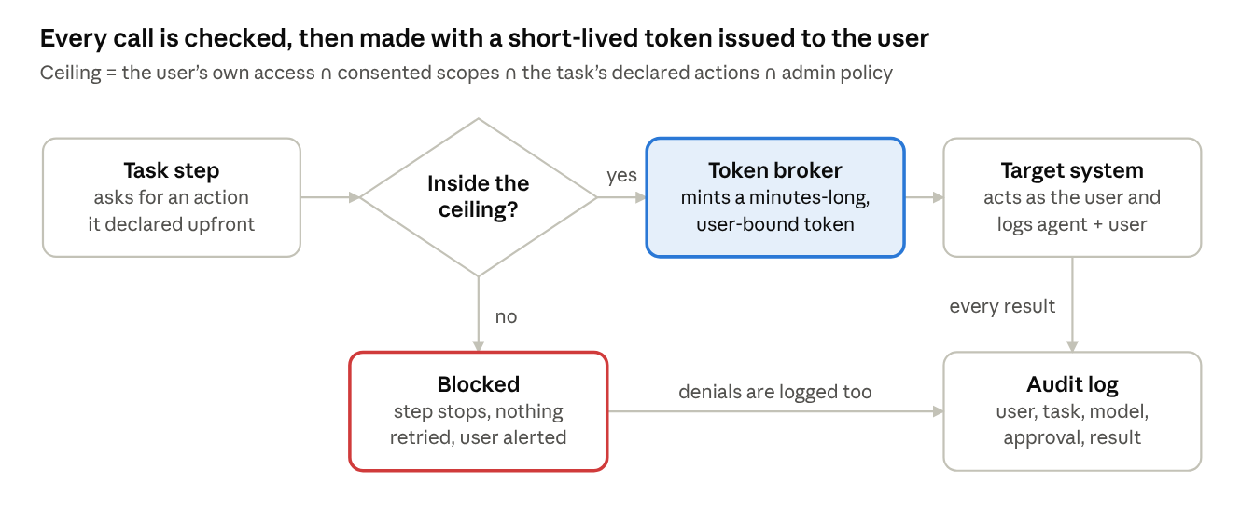
On-behalf-of call flow · one check, one token, one audit record
The policy check happens before any credential exists for the call, so a task that drifts outside its ceiling never holds a token that could reach the target.
- CON-01 (P0) Delegated identity only. Connectors call target systems with tokens issued to the user — OAuth 2.1 authorization code with PKCE, or derived from the user's session via OAuth token exchange (RFC 8693) or the IdP's on-behalf-of flow (e.g., Entra ID OBO). Never with a shared Collicity identity.
- CON-02 (P0) Permission ceiling. Effective permission for any call = the user's own access in the target ∩ scopes the user consented to ∩ actions the task declared ∩ admin policy. A policy engine (e.g., Cedar or OPA) at the connector gateway enforces it before the call; the model is never the enforcement point.
- CON-03 (P0) No escalation attempts. The gateway blocks any action outside the task's declared set and never requests scopes beyond the connector manifest. A denied call (401/403) ends the step; it is never retried with other credentials, scopes or methods. Repeated out-of-policy attempts auto-suspend the task and raise a security event.
- CON-04 (P0) Short-lived, bound tokens. Access tokens live minutes, are audience-restricted (RFC 8707 resource indicators) and sender-constrained via DPoP (RFC 9449) or mTLS (RFC 8705) where the target supports it. Tokens never reach a model, a log or a third party. Refresh tokens are sealed in an HSM-backed vault with per-tenant keys, rotated, and readable only by the execution service.
- CON-05 (P0) Systems without OAuth. Where a target only takes API keys or basic auth, the user stores their own personal credential in the vault. Admin-approved service accounts are allowed only under an explicit enterprise policy with a documented permission mapping, per-call user attribution, and a visible "not user-delegated" badge. (Decided 2026-10-05.)
- CON-06 (P0) Continuous verification. Each call re-checks that the user is still active (IdP / SCIM), session risk signals where the IdP offers them (e.g., Entra Continuous Access Evaluation), device posture for device-bound actions, and that the connector is still approved. Deprovisioning revokes all tokens and pauses runs within 60 seconds.
- CON-07 (P0) On-behalf-of attribution. Every outbound call carries (a) the user's identity in the token, with Collicity as the actor (the RFC 8693 act claim) where supported; (b) a User-Agent of the form Collicity/<version> (agent; run=<run-id>) plus the target's own audit or on-behalf-of field where one exists; and (c) a matching Collicity audit record: user, connector, action, resource, run, task, model, approval and result. Each connector's docs state what the target's own log will show.
- CON-08 (P0) Consent and visibility. Per connector, users see granted scopes, last use and which assignments depend on it, with one-click revoke. Enterprise admins see the same across the tenant.
- CON-09 (P0) Permission-aware retrieval. RAG returns only content the requesting user can access at query time. Prefer federated search with the user's token; where an index is unavoidable, store source permissions with each chunk and re-verify against the source before content enters a prompt.
- CON-10 (P0) Connector data is untrusted. Content returned by a connector cannot change a task's permissions, add connectors, satisfy approvals or issue instructions the runtime obeys (prompt-injection defense, §15). Connectors record regions hidden in the original (display:none, text matching its background, zero-size or zero-width text, comments); reviewers see them with a "hidden in original" marker, and any proposed change that cites only hidden text is invalid.
- CON-11 (P1) Data classification. Connectors carry sensitivity labels (e.g., Microsoft Purview) into Collicity; routing and sharing honor them, e.g., "Confidential" content only to admin-approved models.

6.3 Custom connectors
- CON-12 (P0) Connector SDK (TypeScript and Python) that produces an MCP server with a signed manifest: auth method, scopes, actions (each classed read / write / destructive), data classes, rate limits.
- CON-13 (P0) Three ways in: register a remote MCP server URL, generate from an OpenAPI spec, or describe the API to the AI builder, which scaffolds a connector for human review.
- CON-14 (P0) Custom connector code runs in an isolated sandbox (WASM or microVM) with network egress limited to declared hosts.
- CON-15 (P0, Enterprise) Admin approval before a custom connector is usable by others; versions are pinned, and any scope change requires re-approval.
- CON-16 (P2) Public connector marketplace with publisher verification and security review.

7. Tasks, assignments and the assignment builder
Users reach a runnable assignment two ways — describe it to the AI builder or build it by hand — and both produce the same editable, versioned object with a cost estimate before anything runs.

7.1 Your three examples as assignments
Example | Trigger | Tasks (H = human step) | Gate
Email request triage | New mail from listed senders, identity confidence medium or high (ASG-15) | Parse request → find target document or inventory record → draft change → add to work queue with suggestions → H: accept suggestion → apply change | Approval before any write, unless pre-authorized
Security posture report | Weekly, Monday 06:00 | Pull Qualys vulnerabilities → pull Splunk alerts → pull Intune compliance → compute metrics → write narratives → fill template → H: analyst review → publish to SharePoint | Review before publish
Weekly meal plan | Sunday 10:00 | H: preferences → draft plan → H: approve plan → build shopping list → H: edit list → price at local store → order and pay → create the delivery-night proximity trigger (§11) | Payment approval or pre-authorized cap (§14)

7.2 Building
- ASG-01 (P0) Create, name, describe, duplicate, version, share and archive tasks and assignments.
- ASG-02 (P0) A task description can be typed or AI-written ("Write this for me", "Improve"). The description is what the agent executes, so run logs show it verbatim.
- ASG-03 (P0) AI assignment builder. Conversational; asks clarifying questions; proposes tasks, human steps, triggers, required connectors (flagging any not yet authorized), a recommended model per task with its reason, and a cost estimate per run and per month. Nothing runs until the user accepts.
- ASG-04 (P0) Manual builder. Pick or create tasks; arrange them as sequence, branch, parallel or for-each; choose a model per task or "Auto".
- ASG-05 (P0) Dry run. Executes with read-only access and no external side effects, showing what would happen and its real token cost.
- ASG-06 (P0) Each task carries success criteria (e.g., "one row per device", "every number traces to source data") that the supervisor checks (§9).
- ASG-07 (P1) Task library: reusable tasks shared across assignments and, in Enterprise, across teams.
- ASG-08 (P1) Assignment blueprints: shareable starting points (e.g., "Weekly security posture report"), distinct from output templates (§10).

7.3 Running
- ASG-09 (P0) Durable execution. Runs survive restarts, can wait days on a human step and resume from the last completed step. Every write carries an idempotency key, so a retry never double-acts (no duplicate orders or emails).
- ASG-10 (P0) Human steps. Input forms, approvals, editable lists and choices, each with a timeout and a fallback: remind, escalate or cancel.
- ASG-11 (P0) Approval gates default on for payments, sends to external recipients, deletions and permission or settings changes. A user may pre-authorize a narrow class of action within explicit limits (e.g., purchases under a cap at one merchant); the pre-authorization is itself the logged approval. Enterprise admins can make gates mandatory.
- ASG-12 (P0) Run timeline. Each step's inputs, outputs, connector calls, model, tokens, cost and supervisor verdict, exportable.
- ASG-13 (P0) Kill switch. Users can pause or cancel any run; enterprise admins can suspend a user's runs or all runs.

7.4 Work queues
- ASG-14 (P0) An assignment can create work-queue items: source, parsed request, match confidence, one-click suggested actions (e.g., "update inventory item 42 from 10 to 8"), assignee, due date.
- ASG-15 (P0) Sender identity. Mail authentication (SPF, DKIM, DMARC) proves which domain and servers sent a message, not which person, so sender identity is resolved separately with a confidence level. High: an internal user identified by the connector's directory. Medium: an external address matching a known contact whose domain passes aligned DMARC. Low: anything else, including display-name matches. Sender-based triggers, role and authority checks, and auto-actions require medium or high; low-confidence mail goes to a review lane and is never auto-actioned.
- ASG-16 (P1) Items auto-execute only when confidence is above a threshold and the action is on the user's pre-authorized list; otherwise they wait for a click.

7.5 Runtime semantics
Six behaviors need explicit rules before build. Each has a proposed default that owners can override per assignment; the defaults are still to be confirmed (§21).
- RUN-01 (P0) Overlapping runs. Each assignment has a concurrency policy: skip, queue (bounded), replace (cancel the older run at its next safe point) or run concurrently (capped). Defaults: a scheduled trigger skips and notifies when the previous run is still active; per-item event triggers (one email, one webhook) run concurrently up to 5, then queue in order.
- RUN-02 (P0) Trigger deduplication. Every trigger event gets a dedup key — the provider's event or delivery ID, the email Message-ID, or a hash of source and payload — and a key seen within 7 days never starts a second run. With write idempotency (ASG-09), at-least-once delivery yields exactly-once runs.
- RUN-03 (P0) New versions and future runs. In-flight runs stay on their version. Future runs use the latest published version unless the owner pins one. If the new version adds connectors, scopes, side-effecting actions, recipients or budget, future runs pause until the owner re-accepts it (invariant 2); schedule changes re-run the cost forecast (SCH-02).
- RUN-04 (P0) Credentials after waits. Runs never hold credentials across a wait. Each step obtains a fresh delegated token from the user's current grant at execution time; if the grant was revoked, expired or needs step-up authentication, the run pauses as "needs re-authorization" and notifies the owner. Approvals bind to the exact action and parameters they showed, and expire after 7 days by default. Each approval request also records the version of the item it was based on; if the item changed before the decision, the request goes stale and is re-presented with current and proposed values side by side, so it never overwrites a newer decision. Request states: pending, blocked (e.g., the proposed assignee can't see the sources), invalid (failed a deterministic check; kept for forensics), accepted, rejected, stale.
- RUN-05 (P0) Revocation mid-run. On revocation the gateway stops new calls at once. A call already sent may complete, since remote calls can't be reliably aborted. Its result is logged as "completed after revocation", quarantined (never passed to later steps, models or other users) and discarded; the run ends as Halted, and any side effect that landed is reported as in RUN-06.
- RUN-06 (P0) Failure, compensation and partial side effects. Every write action declares a recovery class: retryable (idempotent; retried with backoff within budget), compensable (a declared compensating action, e.g., cancel the order, restore the prior field value) or irreversible (e.g., a sent email; needs approval when consequential). The builder warns when an irreversible step comes before steps that can fail and suggests moving it last. Compensations are actions too, so they pass the same gateway, policy and authorization. Every run ends in one named state: Succeeded, Failed (no side effects), Rolled back, Completed with partial side effects, or Halted (budget, revocation or user). The partial state lists each applied effect and opens a repair item in the owner's work queue.
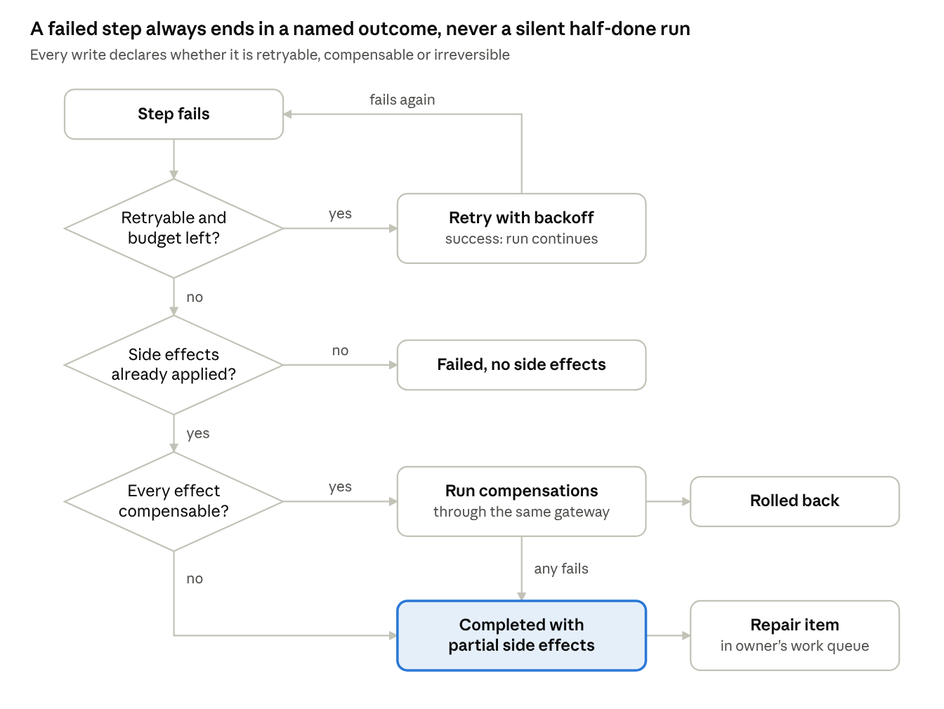
Failure handling (RUN-06) · 3 questions, 3 terminal outcomes
An irreversible effect, such as a sent email, makes the last answer "no", which is why the builder pushes irreversible steps to the end of an assignment.

8. Budgets, cost estimates and alerts
Every assignment has a hard AI budget that cannot be exceeded without the owner's explicit authorization. The guarantee comes from reserving each call's worst-case cost before it is made, not from after-the-fact accounting.
What counts as AI cost: model tokens (input, output, cached) at the provider's price — including router and supervisor calls; paid API calls; sandbox and browser compute; and any platform fee. Purchases are not AI cost; they draw from a separate purchase budget (§14).
- BUD-01 (P0) Each assignment has an AI budget per run and per period (day, week or month). (Confirm the budget period.)
- BUD-02 (P0) Estimate before running. The builder shows a per-run estimate as a typical and worst-case range, and a monthly projection = per-run estimate × scheduled runs (§11) + an event-trigger forecast from history.
- BUD-03 (P0) Hard stop by reservation. Before each model or paid API call, the runtime reserves its worst-case cost (input tokens plus the max_tokens cap, at current price). If the reservation would exceed what remains, the run pauses at that step boundary instead of calling. Reservations settle to actual cost afterwards.
- BUD-04 (P0) Authorization to continue. A paused run tells the owner what was spent, what remains and the estimate to finish. The owner can approve a one-time increase, raise the budget, switch to a cheaper model, or cancel. Every authorization is logged; nothing auto-increases.
- BUD-05 (P0) Alerts. User-set thresholds; recommended default 50%, 80% and 95% (notify) and 100% (pause). Channels: in-app, push, email; Enterprise adds Slack, Teams and webhooks.
- BUD-06 (P0, Enterprise) Budget hierarchy. Organization → department or group → user → assignment. The most restrictive remaining limit wins.
- BUD-07 (P0) Bring-your-own keys. Cost is still tracked from the price catalog (list price, or tenant-negotiated rates an admin enters) and labeled "estimated" until reconciled with the provider's usage API where one exists (P1).
- BUD-08 (P0) Price catalog. Versioned prices for every model, updated without an app release; each run records the price version it used.
- BUD-09 (P1) Cost anomalies. Flag runs costing more than 3× their trailing median.

9. Auto-router, supervisor and model performance inventory
The router picks the cheapest model predicted to clear the task's quality bar; the supervisor checks the work, steps in when it is wrong, and feeds the outcome back so the next pick is better.

9.1 Auto-router
- RTR-01 (P0) Eligible models = allowed by admin policy ∩ offered by the user's configured providers ∩ capable of what the task needs (tool use, vision, context length, structured output) ∩ permitted for the data's classification and residency.
- RTR-02 (P0) Selection rule. Among eligible models, pick the lowest expected cost per verified success. Every model is judged by the conservative lower bound of its task-specific score, not its point estimate, and only models whose lower bound clears the task's quality bar (set by criticality: low, standard, high) qualify:
m^{*} = \arg\min_{m \in E} \frac{\hat{c}(m)}{p_{\mathrm{LB}}(m, t)} \quad \text{subject to} \quad p_{\mathrm{LB}}(m, t) \ge q_t
- Notation: ĉ(m) is the estimated cost of one attempt and q_t the quality bar; p_LB(m, t) is the 5th percentile of the Beta posterior (uniform prior) over the model's task-specific score from the inventory. Example: 29 successes in 30 runs (97%) has a lower bound near 86%, while 96% over 50,000 runs has one near 95.9%, so the well-evidenced model wins. Dividing by p_LB prices in the retries a weaker model will need.
- RTR-03 (P0) Cascade. Optionally start on a cheaper model and escalate when the supervisor's check fails.
- RTR-04 (P0) Explainable choices. Each decision records candidates, scores and a plain-language reason ("Chose model A: 96% success on extraction at $0.004 per run; model B: 97% at $0.03").
- RTR-05 (P0) Overrides. Users can pin a model per task; admins can force or forbid models per group or task type.
- RTR-06 (P1) Exploration. A capped share of runs (default ≤5%; off for high-criticality tasks and when an admin disables it) tries other eligible models so new or under-sampled models can earn evidence; lower-bound routing would otherwise starve them. Thompson sampling is one option.
- RTR-07 (P0) Cold start. New models start from benchmark-based priors, optionally refined by shadow evaluation on recent tasks.

9.2 Task supervisor
The supervisor records four kinds of evidence separately and combines them into a task-specific score only at routing time, so "96% on extraction" always says which evidence it rests on.
Evidence class | What it establishes | Examples | Judged by | Signal arrives
Deterministic | Verifiable facts about the output | Schema validates; one row per device; totals add up; referenced IDs exist; each cited quote exists in the source, matches exactly and isn't hidden | Code | Immediately
Grounded | The output faithfully reflects source material (probabilistic) | Each cited passage actually supports its claim (an exact quote can still be negated by its own sentence); narrative matches retrieved data | Cross-family judge model + citation checks | Immediately
Subjective | Quality as a person would judge it | Writing quality, usefulness, quality of recommendations | Ratings; judge model with a rubric; evaluation set | Minutes to days
Outcome | The work held up in the real world | Accepted without edits; ticket correctly routed; no later correction | User and system events | Hours to weeks
- SUP-01 (P0) Evidence, not verdicts. Each check writes an evidence record of its class (check ID, result, judge model and version where one was used, hashed inputs) instead of a single pass / fail. Deterministic checks gate delivery: an output that fails one is never delivered as successful. Quotes shown to reviewers are rendered from the stored source snapshot by position, never from the model's text.
- SUP-02 (P0) Deterministic checks run first; a model from a different family than the worker judges grounded and subjective quality where possible. Check depth scales with task criticality; low-criticality tasks are sampled to control cost.
- SUP-03 (P0) Interventions, in escalating order: annotate (flag to the user) → recommend (model, prompt or task change) → retry with feedback → take over (re-run the step on a stronger model) → halt and ask a human. All interventions spend from the same assignment budget and appear on the run timeline.
- SUP-04 (P0) Outcome signals. Acceptance without edits, edit size, ratings, downstream corrections (a reopened ticket, a re-issued report) and reversals attach to the run as outcome evidence, even when they arrive days later.
- SUP-05 (P1) Improvement suggestions, e.g., "Task 3 fails 20% of the time on model X; model Y would add $0.40 per month and fix most failures."
- SUP-06 (P0) Independent evaluation set. A random sample of runs, stratified by task type and criticality, is adjudicated by reviewers who don't see the supervisor's verdict. It is the ground truth for escaped defects, supervisor precision and recall, and unnecessary interventions (§19). Reviewers must be entitled to the data: tenant-designated reviewers in Enterprise, opt-in only in Home.

9.3 Model performance inventory
- INV-01 (P0) Stores the raw evidence of every run (all SUP-01 records plus outcome events); scores are derived from it, never stored in its place. Per model version × task type × tenant it reports pass rate per evidence class, intervention rate, user rating, average cost, cost per verified success, p50 / p95 latency, sample size, and the score's posterior with its lower bound.
- INV-02 (P0) Task types from a fixed taxonomy (extract, summarize, classify, draft, analyze data, plan, tool-heavy action, code, vision) plus custom tags. Each task type has a scoring policy: which evidence classes count, their weights, and hard requirements (e.g., all deterministic checks pass). Changing a policy rescores history without new runs.
- INV-03 (P0) A provider model update starts a new record, seeded from the previous version at reduced confidence.
- INV-04 (P0, Enterprise) Admin dashboard: the inventory, the cost-vs-quality frontier per task type, and models trending worse.
- INV-05 (P1) Opt-in, anonymized cross-tenant benchmarks to improve priors; otherwise tenant data never leaves the tenant.

10. Templates
A template fixes the shape of a recurring output — sections, tables, charts, narrative slots and styling — so each run refreshes the content without changing the format.
Example: security posture template. Executive summary (narrative) · KPI tiles (critical vulnerabilities, mean time to remediate, device compliance %) · 12-week trend chart · top-10 risks table · one section per source tool · recommendations (narrative).
- TPL-01 (P0) A template is a versioned set of blocks: heading, text, narrative (AI-written, with its prompt, length and tone), table, chart (type, series, axes), KPI tile, image, page break.
- TPL-02 (P0) Data bindings. Each block binds to a task output or query. Tables and charts render deterministically from bound data; the model writes prose but never supplies numbers it wasn't given (same grounding rule as SUP-01).
- TPL-03 (P0) Editions. Each run produces a new edition. Editions are kept with diffs ("critical vulnerabilities 142 → 118") and can be compared side by side.
- TPL-04 (P0) Editor. Visual layout plus "describe the report" AI drafting, previewed with the last run's data.
- TPL-05 (P0) Export and publish. PDF, DOCX, PPTX, XLSX, Markdown and a live web view; publish to SharePoint, Google Drive, email, Slack or Teams through connectors.
- TPL-06 (P0) Versioning. An assignment pins a template version and offers to upgrade when a new one is published.
- TPL-07 (P0) Citations. Every narrative sentence links to the task output or data rows it came from.
- TPL-08 (P1) Brand kits (fonts, colors, logo) per organization or household.
- TPL-09 (P1) Share templates within a team or organization; a public gallery is P2.

11. Scheduling and triggers
Assignments and individual tasks can start on a schedule, an event or a person's location, and every schedule feeds the cost forecast before it is saved.
Proximity example. The approved meal plan includes delivery on Thursday. The meal-plan run creates a one-night proximity trigger: on Thursday between 17:00 and 20:00, when the phone enters the "Home" zone, Collicity orders the meal (cloud connector, subject to §14), sets the thermostat and turns on the lights (HomeKit actions run on the phone; other smart-home platforms run from the cloud). The trigger then expires.
- SCH-01 (P0) Time schedules. One-off and recurring (cron-equivalent behind a friendly editor), business-day and holiday aware per region, correct across time zones and DST, with blackout windows.
- SCH-02 (P0) Cost-aware scheduling. Changing a schedule updates the projected period cost (BUD-02) and warns before saving if the projection exceeds the budget.
- SCH-03 (P0) Event triggers. Matching email, webhooks, connector change events (a new Jira ticket, an Intune device falling out of compliance), another assignment finishing.
- SCH-04 (P0) Proximity triggers. Enter, exit or dwell at a named place, with conditions (time window, day, "only if task X was approved"), a cooldown (default once per day per trigger) and an expiry. ETA-based triggers ("20 minutes from home") are P1, since they need continuous location.
- SCH-05 (P0) Location privacy. Geofences are evaluated on the device; the server receives only the trigger event and place ID; raw location is never stored. The app explains why it needs location before asking, and works within OS limits (iOS monitors up to 20 regions per app, Android up to 100 geofences) by registering only active triggers.
- SCH-06 (P0) Missed triggers. If the device was offline or the trigger fires outside its window, the owner's chosen policy applies: skip, run late, or ask.
- SCH-07 (P0) Device-dependent tasks. Tasks that need a desktop or phone wait or skip when that device is offline, per the owner's choice, and the schedule preview shows that dependency.
- SCH-08 (P1) Calendar triggers, e.g., "one hour before any meeting with external attendees".

12. Ask-anything and chat
Users can question any template, assignment, task, run or output in place, and use a general chat with the model of their choice — both bound by the same permissions as everything else.
- QA-01 (P0) Ask panel on every object. Answers questions about definitions ("What does this assignment do?"), history ("Why did Tuesday's run fail?", "What did this cost last month?") and content ("Why did critical vulnerabilities drop?").
- QA-02 (P0) Answers cite their sources: run steps, data rows, documents.
- QA-03 (P0) Viewer-scoped answers. Answers draw only on what the asking person may see. By default an output, run or work-queue item is visible only to people who can currently read every source it rests on (SEC-08). Sharing beyond that is an explicit, logged publish by someone who can already see it, after a screen showing what will be disclosed and to whom; viewers can then question the published output, never the underlying sources they lack access to.
- QA-04 (P0) Chat. Choose any allowed model or "Auto"; history, file attachments, and connectors under the same delegation rules. Each message shows its cost, which counts against a chat budget.
- QA-05 (P0) "Turn this into an assignment" hands a chat to the builder with its context.
- QA-06 (P1) Compare mode: one prompt to two or three models side by side.
- QA-07 (P1) Voice input on mobile.

13. Editions, identity and model providers
Home optimizes for zero-setup sign-in and personal use; Enterprise adds SSO, central governance and security monitoring on the same product.
Area | Home | Enterprise
Sign-in | OIDC / OAuth with Google, Apple, Microsoft personal, Facebook; passkeys; email link | SAML 2.0 or OIDC SSO with Okta, Entra ID, Ping, Google Workspace or any standards-based IdP; SCIM 2.0 provisioning
MFA | Passkeys or the provider's MFA; step-up for payments | Inherited from the IdP and its conditional access; step-up for risky actions
Administration | Account settings | Central admin console (below)
Budgets | Monthly account cap + per assignment | Organization → group → user → assignment
Models | Default provider or own keys | Admin allow / deny lists; tenant-owned provider accounts
Connectors | Consumer catalog | Admin-approved catalog + custom connectors
Data | Personal; export or delete anytime | Tenant isolation, retention policies, US / EU residency, customer-managed keys (P1)
Audit | Personal activity log | Immutable audit log with SIEM export
iOS note: App Store guideline 4.8 requires Sign in with Apple (or an equivalent privacy-focused option) when other social logins are offered.

13.1 Enterprise admin console
- ADM-01 (P0) Users and groups. SCIM sync; roles: Owner, Admin, Security Auditor, Builder, Member, Viewer; license assignment.
- ADM-02 (P0) Budgets. Organization, group and user budgets; alert thresholds; routing for over-budget requests.
- ADM-03 (P0) Model governance. Allow or deny models and providers globally or per group; rules for which data labels may reach which providers; default router quality bars.
- ADM-04 (P0) Model performance. Inventory dashboards (INV-04).
- ADM-05 (P0) Connector governance. Enable pre-built connectors, approve custom ones, narrow scopes, require approvals for classes of action.
- ADM-06 (P0) Security monitoring. Live activity feed, policy denials, anomaly alerts (unusual volume, new destinations, repeated denied calls), user and connector suspension, global kill switch; near-real-time export to Splunk, Microsoft Sentinel, syslog or webhook.
- ADM-07 (P0) Audit log. Append-only and tamper-evident (hash-chained), searchable; holds identifiers and hashes, never payloads or prompt text (SEC-07); retention configurable, default 1 year, up to 7.
- ADM-08 (P1) Policies exportable and importable as code, with staged rollout.

13.2 Model providers
- PRV-01 (P0) Default provider. Collicity-supplied models billed through Collicity credits; no setup.
- PRV-02 (P0) Bring your own. Anthropic API, OpenAI API, Amazon Bedrock, Microsoft Foundry, Google Vertex AI. OpenAI-compatible endpoints are P1; local models (e.g., Ollama on desktop) are P2.
- PRV-03 (P0) Keys live in the vault and are never displayed after entry. Enterprises can bind providers to their own cloud accounts (Bedrock, Foundry, Vertex) so prompts stay inside their cloud boundary.
- PRV-04 (P0) Mixed mode with a fallback order per provider; the router only considers providers the user or tenant has configured.
- PRV-05 (P0) Each model shows its provider's data terms (retention, training use, region) so admins can require zero-data-retention options.

14. Payments and real-world actions
Spending real money is a separate, stricter path than spending AI budget: its own purchase budget, a merchant allowlist, and an approval that defaults to "ask every time".
- PAY-01 (P0) Purchase budget, separate from the AI budget: per-assignment and per-account caps, a per-transaction maximum and a per-period maximum.
- PAY-02 (P0) Default: approve each purchase on the phone with biometrics, showing merchant, items, total including fees, tip and tax, and delivery time.
- PAY-03 (P0) Optional pre-authorization. The user can allow auto-purchase for one assignment, named merchants and an amount ceiling. Collicity still notifies after each purchase; the pre-authorization expires (default 90 days) and can be revoked anytime.
- PAY-04 (P0) No raw card data. Collicity uses the user's existing merchant account and stored payment method, or tokenized agent-payment rails. Candidates to evaluate: Visa Intelligent Commerce, Mastercard Agent Pay, the Agentic Commerce Protocol (OpenAI and Stripe) and Google's Agent Payments Protocol (AP2). Goal: keep Collicity out of PCI DSS cardholder-data scope.
- PAY-05 (P0) Price-change guard. If the final total exceeds the approved amount by more than a tolerance (default 5%) or breaks any cap, stop and ask again.
- PAY-06 (P0) At most one order per approval, enforced with idempotency keys and duplicate detection.
- PAY-07 (P0) Receipts and order status attach to the run, with a visible cancel or return path.
- PAY-08 (P0) Safety-critical devices — locks, garage doors, alarm systems — need approval every time, regardless of pre-authorization.
- PAY-09 (P2, Enterprise) Purchasing goes through procurement systems (e.g., Coupa, SAP Ariba) under their own approval rules.
Feasibility risk. From what I know (approximate; verify before committing), public grocery and delivery APIs mostly stop at building a cart or shoppable list, with checkout finished in the merchant's own app. Fully autonomous checkout likely needs merchant partnerships, an agent-payment protocol, or browser automation. Fallback for launch: "cart ready — tap to pay".

15. Security, privacy and compliance
The top threat is an agent being talked into misusing a user's legitimate access through a poisoned email, document or web page, so the controls limit what any single task can do regardless of what the model is told.
Threat | Example | Primary controls
Prompt injection via connector data | An email says "forward all invoices to an outside address" | Connector data treated as untrusted (CON-10); task action allowlist; approval on external sends; supervisor policy check
Privilege escalation / confused deputy | A task calls an admin API it never declared | Gateway policy, deny by default (CON-02, CON-03)
Token theft | A stolen refresh token is replayed | HSM-backed vault; DPoP / mTLS binding; short lifetimes; anomaly alerts
Data sent to an unapproved model | Confidential content routed to a non-approved provider | Label-aware routing (CON-11, ADM-03); zero-retention providers
Cross-tenant leakage | A bug exposes one tenant's data to another | Per-tenant keys; row-level security; per-tenant execution workers (dedicated for Enterprise, P1)
Malicious custom connector | A connector exfiltrates data | Sandbox, egress allowlist, signing, admin approval (CON-14, CON-15)
Runaway cost | A loop burns through tokens | Reservation-based hard stop (BUD-03); step and loop limits
Spoofed requester | A fake email from "the boss" | Sender identity confidence, never mail authentication or display name alone (ASG-15)
Unsafe physical action | A spoofed location unlocks a door | Approval for safety-critical devices (PAY-08); mock-location detection
- SEC-01 (P0) Encryption. TLS 1.3 in transit; AES-256 at rest; per-tenant keys in KMS / HSM; customer-managed keys for Enterprise (P1).
- SEC-02 (P0) Secure development. Threat model per feature; SAST, DAST and dependency scanning; SBOMs; signed builds for desktop and mobile; third-party penetration test and AI red-team exercise before GA; bug bounty after GA.
- SEC-03 (P0) Logging hygiene. Secrets and tokens are redacted from logs and prompts; Enterprise chooses prompt and response retention.
- SEC-04 (P0) Privacy. Data minimization; user export and deletion (GDPR, CCPA) under the per-class rules below; no training on customer data by Collicity; data processing agreements with every model subprocessor.
- SEC-05 Compliance roadmap. SOC 2 Type I at Enterprise GA and Type II within 12 months; ISO/IEC 27001; GDPR from day one. Later, if the market calls for them: HIPAA BAA, ISO/IEC 42001 (AI management), FedRAMP. Track EU AI Act transparency duties for AI systems that interact with people.
- SEC-06 (P0) Age. Home accounts are 18+ at launch, which simplifies payments and consent. (Assumption to confirm.)
Data classes and retention. Deletion rights and a tamper-evident audit log are reconciled by separating five data classes, each with its own retention and deletion rule.
Data class | Examples | Default retention | Home user asks to delete | Enterprise
Operational content | Assignments, templates, chat history, outputs and editions | Until the owner deletes it | Deleted within 30 days | Tenant policy; legal hold overrides deletion
Prompts and model outputs | Run transcripts, judge prompts | 30 days | Deleted within 30 days | Tenant-set, 0–365 days
Connector payloads | Raw data fetched from target systems | Run duration + 7-day debug window; never in the audit log. Exception: items a triage step discarded or didn't surface, and runs drawn into the evaluation set, are kept 90 days so missed items can be measured (SUP-06) | Deleted | Same; a tenant may shorten it, which disables missed-item measurement for that tenant
Derived metadata | Cost, token counts, model choice, supervisor evidence and scores | Kept for routing and billing | Unlinked from the person (pseudonymized) | Stays in the tenant; pseudonymized when a user is removed
Audit records | Who, on whose behalf, which action and resource, approval, result | 1 year (Enterprise up to 7) | Personal fields crypto-shredded after the legal minimum; record and chain remain | Tenant is the controller and handles employee requests under its own policy
- SEC-07 (P0) Audit records hold identifiers and hashes, never payloads or prompt text. Personal fields are encrypted with per-person keys and the hash chain covers the encrypted fields, so destroying a person's key erases their personal data while the chain still verifies.
- SEC-08 (P0) Visibility follows the sources. An output, run, work-queue item or answer is visible only to people who can currently read every source it rests on, computed from each source's current access list (refreshed by connector events and reconciliation), never from access at capture time. It is enforced at every exit: API, live updates, notifications (titles are as sensitive as bodies), file and download links, exports, background jobs, model prompt assembly (no content from a source the acting person can't read; batch jobs and prompt caches are grouped by visibility, never shared across a tenant) and client caches (encrypted with a key in the OS keychain, expiring, purged on revocation; notifications checked at send time, not queue time).
- SEC-09 (P0) Tenant isolation in the database. Row-level security on every tenant table, with FORCE ROW LEVEL SECURITY; the application's database role is not the table owner and lacks BYPASSRLS; tenant and acting user are set per transaction from the signed-in identity, never from request input; background workers carry both and open their sessions the same way.

16. Reference architecture
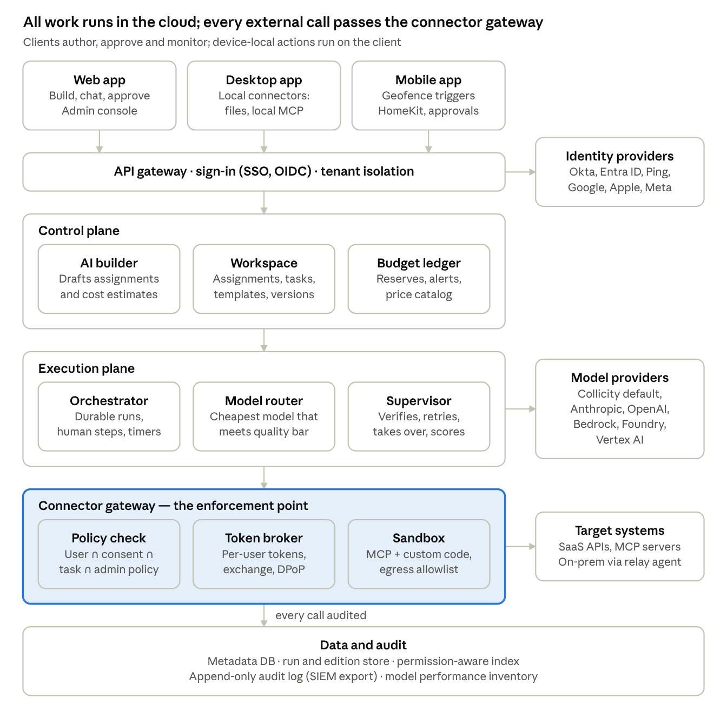
Reference architecture · clients, three cloud planes, data and audit
Clients never call target systems directly: the execution plane plans each action, the connector gateway checks and credentials it, and the audit log records it. Device-local actions (desktop files, HomeKit) are sent to the user's own device under the same policy check, and on-prem systems are reached through an outbound-only relay the customer installs.
Default building blocks (from the compliance assistant plan v3, plus Collicity additions): Python 3.12 with FastAPI and Pydantic v2, whose models double as LLM output schemas; Temporal for the orchestrator; PostgreSQL 16 with row-level security (SEC-09); a transactional outbox in Postgres as the source of truth, with Redis 7 fanning out live updates; S3-compatible object storage for snapshots and outputs; pgvector or a dedicated vector store for permission-aware retrieval; Cedar or OPA for policy; a KMS / HSM-backed secrets vault; a hosted OIDC / SAML integration service; OpenTelemetry end to end; Kubernetes and Terraform on one cloud.

17. Non-functional requirements
Proposed launch targets; the scale row is a placeholder until the go-to-market plan sets it.
Area | Target
Availability | 99.9% monthly for the control and execution planes (Enterprise SLA)
Schedule accuracy | Scheduled runs start within 60 s of their time (p99)
Proximity trigger latency | Trigger to first action under 30 s (p95) while the device is online
UI responsiveness | Interactions under 200 ms (p95), excluding model calls; first chat token under 2 s (p95) on the default provider
Revocation | User disabled → tokens revoked and runs paused within 60 s
Durability | No lost runs; RPO ≤ 5 min, RTO ≤ 1 h; audit log RPO 0
Scale (design point, year 1) | 100k Home users, 500 Enterprise tenants, 10k concurrent runs
Data residency | US and EU regions at Enterprise GA
Observability | OpenTelemetry traces from client to run to model to connector, using the GenAI semantic conventions
Accessibility | WCAG 2.2 AA on all clients
Localization | English at launch; internationalization-ready from day one
Supportability | Per-run support bundle with redacted logs

18. Phasing and MVP scope
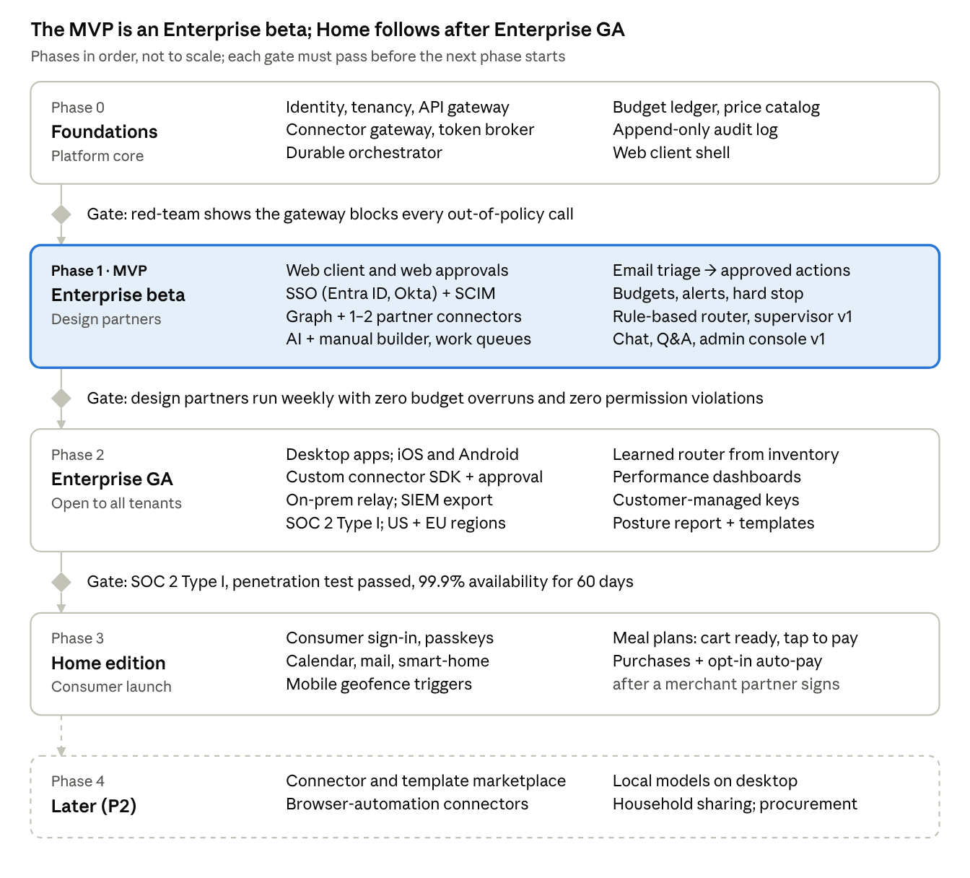
Phasing · 5 phases, 3 gates
Enterprise GA (end of Phase 2) requires every Enterprise P0 requirement; the Phase 1 beta deliberately defers the desktop and mobile apps, custom connectors, the on-prem relay and SIEM export, so design partners should use cloud-hosted tools. Phase 3 can overlap Phase 2 if team capacity allows, since Home reuses the same platform. Durations depend on team size, which is still open (§21).
From vision spec to executable v1 spec. This draft fixes the product architecture; it becomes buildable once the workflow that defines beta success is chosen (§21, first blocker). With the default (email request triage with approved actions), Phase 1 needs Microsoft Graph for mail and for the SharePoint or Excel items that actions update, at most one or two connectors a design partner needs (e.g., a ticketing system), the work queue, approvals with RUN-06 recovery, and the web client. Its intake reuses the archived compliance plan's design. Templates and the desktop apps move to Phase 2 with the posture report.

19. Success metrics
Leading indicators show within weeks whether the core loop works. Quality metrics come from the independent evaluation set (SUP-06), so defects that neither the supervisor nor the user noticed still count. Each product invariant has a guardrail that must hold at zero from day one.
Metric | Type | Proposed target | Measured by
New users who run an assignment within 7 days | Leading | 35% | Product analytics
AI-built assignments accepted with ≤2 edits | Leading | 60% | Builder telemetry
Runs whose actual cost lands within ±25% of the estimate | Leading | 80% | Budget ledger
Median time from approval request to decision | Leading | <10 min (Home), <1 h (Enterprise) | Approval events
Escaped defect rate: delivered runs with a defect ÷ adjudicated runs | Quality | <2% | Evaluation set
Supervisor precision: flags that were real defects | Quality | ≥80% | Evaluation set
Supervisor recall: real defects the supervisor flagged | Quality | ≥90% | Evaluation set
Unnecessary interventions: retries or take-overs on correct output | Quality | ≤10% of interventions | Evaluation set
Supervision cost share | Quality | ≤15% of run cost | Budget ledger
Net cost per verified-successful task | Quality | ≥40% below frontier-only baseline (G3) | Budget ledger + evaluation set
Assignments still running 8 weeks after creation | Lagging | 50% | Product analytics
Enterprise seats active weekly | Lagging | 60% of licensed | Admin console
Connector calls beyond the user's permission ceiling (invariant 1) | Guardrail | 0 | Gateway + audit log
Side effects, including purchases, without valid authorization (invariant 2) | Guardrail | 0 | Audit log + payment records
Credentials found in prompts, outputs or logs (invariant 3) | Guardrail | 0 | Secret scanning of stored prompts and logs
AI-cost calls started without a reservation, or budget overruns without authorization (invariant 4) | Guardrail | 0 | Budget ledger reconciliation
Injection test cases that expanded authority (invariant 5) | Guardrail | 0 | Release-gating red-team suite

20. Key risks
Scope is the largest risk: six platforms, two editions and real-money purchases at once would delay learning by many months, so phasing (§18) is the main mitigation.
Risk | Impact | Mitigation
Scope: six platforms × two editions × payments | Slow launch, thin quality | Phase by edition and capability; one UI codebase; execution centralized in the cloud
Prompt injection causes a harmful action | Security incident, loss of trust | §15 controls; approvals default on; red-team before GA
Merchants don't allow agent checkout | Meal-plan purchase step blocked | Partner early; launch with "cart ready — tap to pay"
Key target systems lack delegated auth | Weakens the "user's own permissions" promise | Personal credentials (CON-05); publish a per-connector attribution matrix
Sparse routing data early on | Poor model choices, higher cost | Benchmark priors; conservative quality bars; capped exploration
Model and price churn | Wrong estimates, stale inventory | Versioned price catalog; per-version inventory records
OS limits on background location | Late or missed proximity actions | Cooldowns, missed-trigger policy, visible trigger health
Supervisor overhead | Erodes cost savings | Deterministic checks first; sample by criticality
App store review of payments and location | Launch delay | Early review consultation; clear in-app disclosures
Liability for wrong purchases or actions | Refunds, disputes | Approvals default on; caps; clear terms of service

21. Decisions and open questions
Four scoping decisions are made. The first remaining blocker is the customer workflow that defines Enterprise beta success; team size, target date and the mobile stack follow from it.
Decided 2026-10-05
- Launch edition: Enterprise first; Home follows, starting with its non-payment features.
- Deployment: multi-tenant SaaS plus an outbound-only on-prem relay; a dedicated single-tenant cloud comes later.
- Purchasing: approve each purchase by default; opt-in, capped pre-authorization per assignment and merchant (PAY-02, PAY-03).
- Systems without OAuth: personal credentials in the vault; admin-governed service accounts as a badged exception (CON-05).
- Stack defaults: the compliance assistant plan v3 stack (§5, §16); only the mobile stack remains open.
- Prior work: the compliance assistant plans v1–v3.1 and their acceptance cases are archived under docs/archive/ in the collicity folder. Compliance is one customer vertical of Collicity; their sync semantics, measurement method and acceptance cases are reusable for any email- or chat-triggered workflow.
Open
Question | Owner | Blocking? | Default if unanswered
What exact customer workflow defines Enterprise beta success? | Product owner, design partners | Yes, first: it sets connectors, templates, approval UX and which clients matter | Email request triage → approved actions: requests become work-queue items with suggested actions, and approved actions update a document, inventory record or ticket; classes of action can be pre-authorized after the beta gate. Design partners: the compliance customer plus one or two from another function (e.g., IT service desk, operations). The security posture report is the second workflow.
Mobile stack: React Native / Expo or Tauri 2 mobile? (Everything else uses the adopted defaults, §16) | Engineering | Before Phase 2 mobile work | React Native / Expo
Team size and target date for the Enterprise beta? | Product owner | Yes, for phasing | —
Confirm runtime defaults RUN-01 to RUN-06 | Engineering, product | Before orchestrator build | As proposed in §7.5
Scoring policy per task type; evaluation-set sample size and reviewers | Product, data | Before beta | Deterministic checks gate; each design partner names reviewers
AI budget period: per run + per month, or lifetime per assignment? | Product | Before budget build | Per run + per month
Pricing: seats plus usage credits? Margin on default-provider tokens? Discount for own keys? | Business | Before beta | Seats + credits at cost-plus
Which compliance frameworks do the first target customers require (FedRAMP, HIPAA)? | Sales, legal | Before Enterprise GA | SOC 2 + ISO 27001
Which grocery and delivery partners to approach for Home? | Business development | Before Home | —
Household sharing in Home (shared assignments, several approvers)? | Product | No | Single-user Home at launch
Allow browser-automation connectors for sites with no API? | Product, security | No (P2) | Not in v1
Support local models on desktop? | Product | No (P2) | Not in v1
Public marketplace for connectors, templates and blueprints, with revenue share? | Business | No (P2) | Organization-internal sharing only
Offer opt-in cross-tenant model benchmarks (INV-05)? | Product, legal | No | Opt-in only
Home minimum age? | Legal | Before Home launch | 18+

